**Basic Queries Outputs**

**#1 Create and Show Database :**

**Output:**



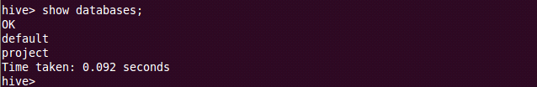

**#2 Use Database:**

**Output:**



**#3 Create cse, ece and bt tables:**

**Output:**

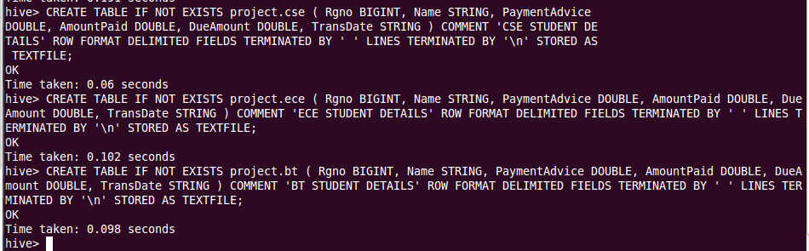

**#4 Show tables:**

**Output:**

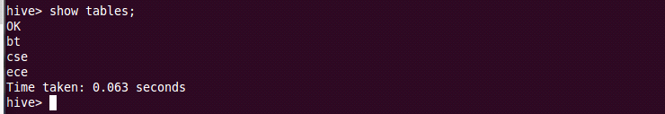

**#5 Load values into the tables:**

**Output:**

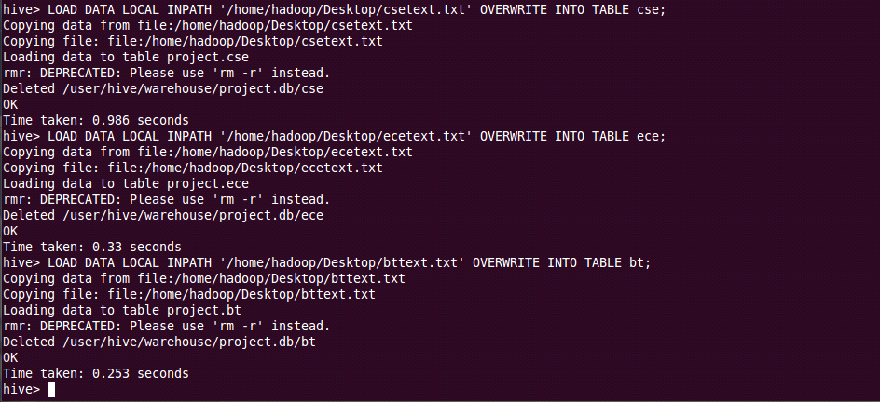

**#6 Show all the tables content:**

**Output:**

